**QSMART – LASER ADJUSTMENT**

**PROCEDURE**

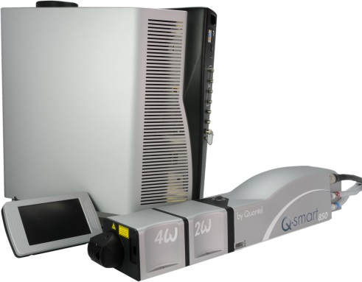

**Toolkit:**

Allen keys

Energy meter

Photodiode

Oscilloscope

**System** : QSMART

|  |  |  |  |
| --- | --- | --- | --- |
|  |  |  |  |
|  |  |  |  |

**Purpose**: This document details how to change align the laser components

|  |  |  |
| --- | --- | --- |
| Revision | date | modification |
| Initial issue | July 4, 2014 |  |
| Rev. B | May 7, 2015 | Add free running checking |
|  |  |  |
|  |  |  |

# ADJUSTMENT OF THE LASER (Spiricon or Burn Paper)

* Connect the Laser head to the power supply
* Connect the coolant hoses (respect the color)
* Switch on the power supply
* Check that the Shutter LED on the head lights up then lights out.
* Adjust the level of water
* Set up the Special tool for interlock cover head RM100016A
* Disconnect the Qtouch and plug the RJ45 ethernet cable
* Launch the Qsmart-Service.exe application on your computer

Qsmart-Service application

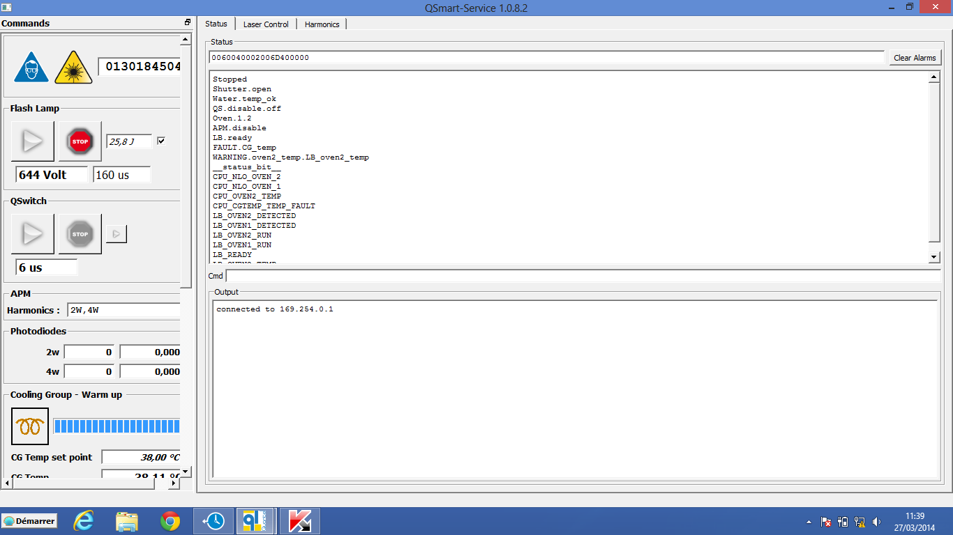

* If there is any communication between the Qsmart-Service application on your computer and the power supply, adjust the parameter of IP address on your lab top. Enter 169.254.0.10

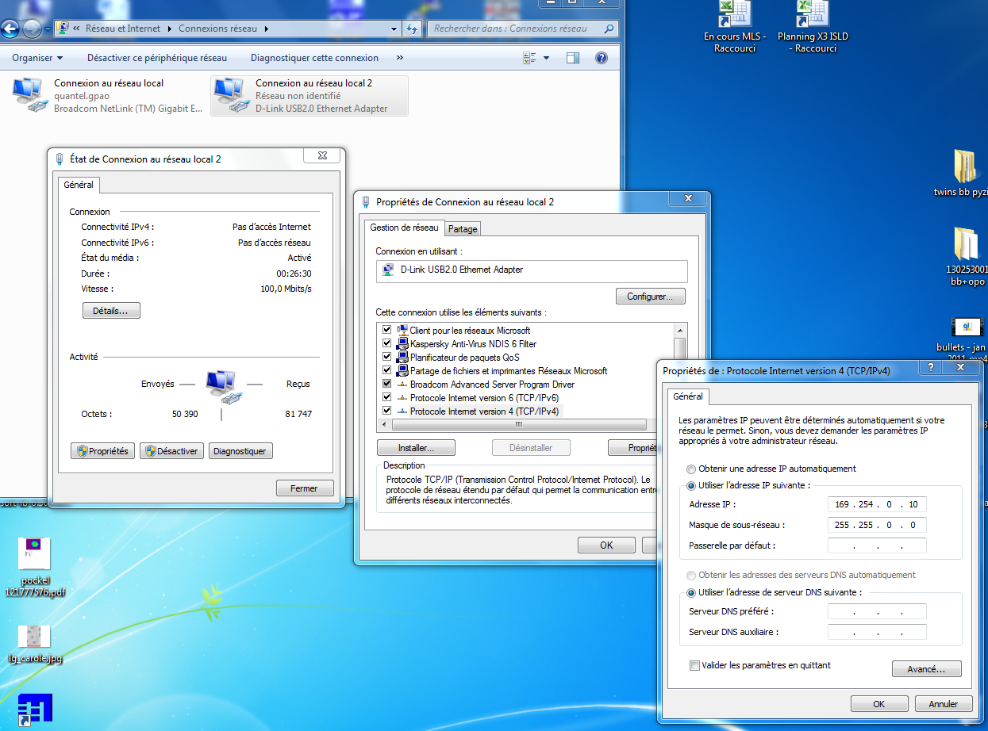

* Open the file : Modulo.ini and enter the IP 169.250.0.1

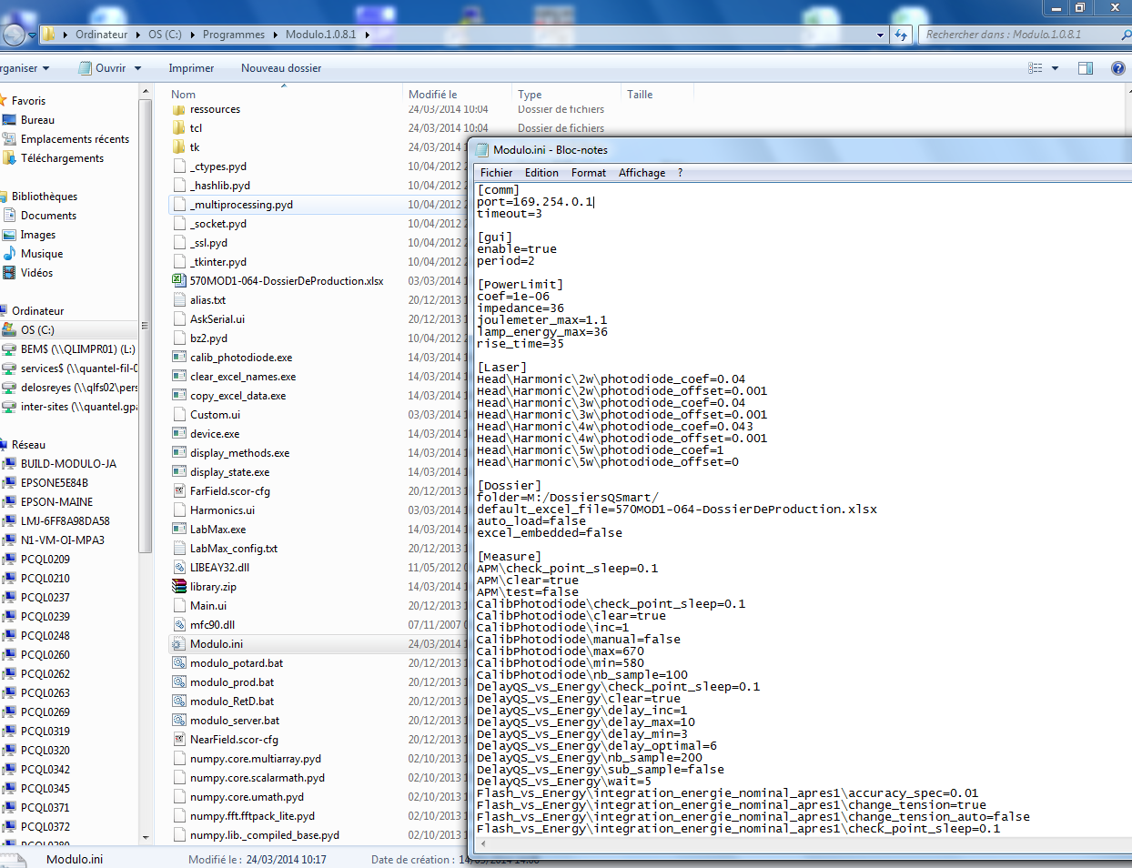

Now, the communication is establish

Let us return on the Laser head adjustment

### Remove the ¼ wave plate (which permits holdoff)

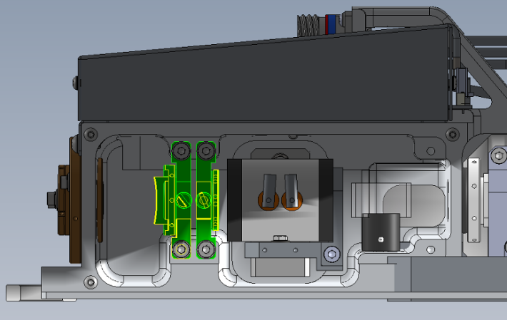

* Set and Check :
  + - Flash voltage: 600V
    - Charger set point  160µs
    - Shutter head is open

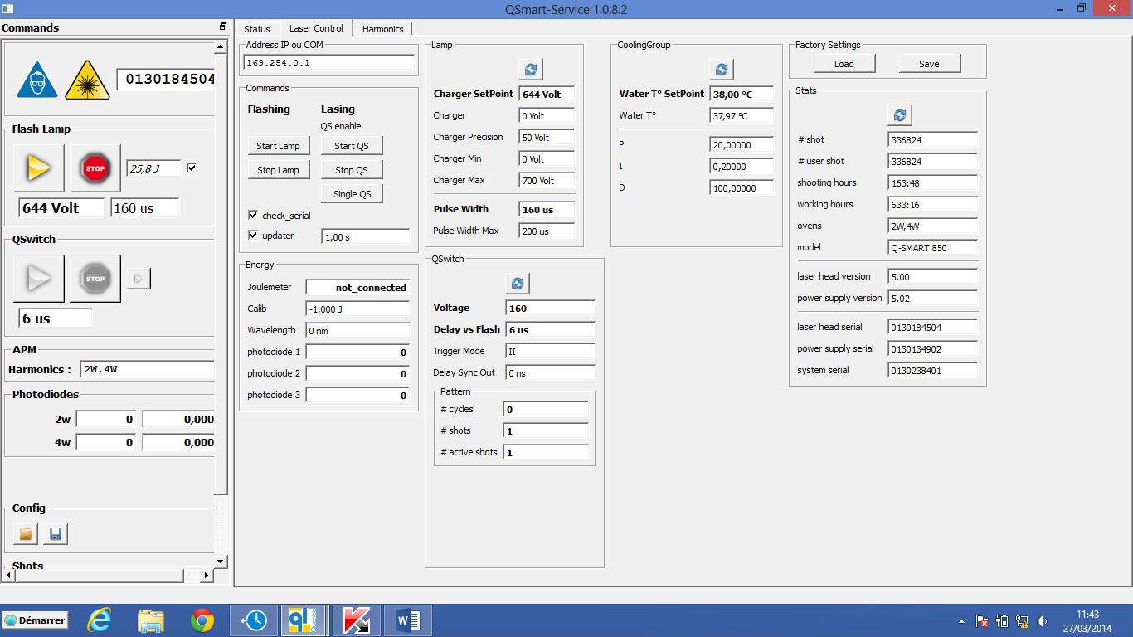

* **Start the flashlamp ONLY**
* Align the rear mirror in order to have a round shape on the CCD Spiricon camera or on a burn paper.

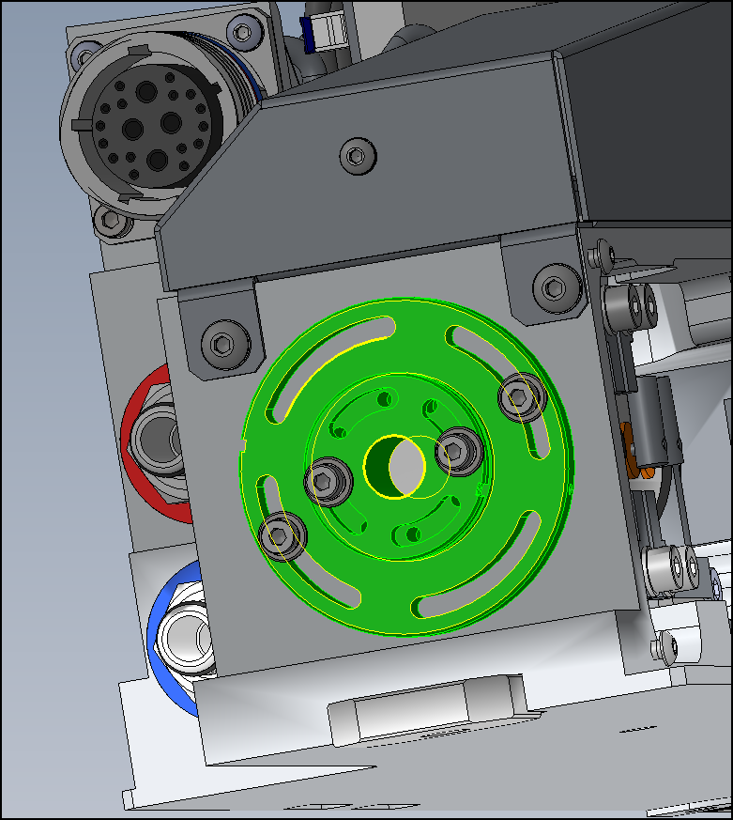

* Optimize the output energy by turning the second ¼ wave plate located at the front of the Laser head
* Adjust the energy to 850mJ by increasing the Flashlamp Voltage «Charger set point»
* Remove the power meter and check the beam again
* Stop the flash lamp
* Re-install the hold off ¼ wave plate
* Start the flash lamp
* Plug a photodiode to a scope in order to look the flash lamp fluorescence
* Rotate the ¼wave plate to establish hold off
* If there is still free running, adjust the Pockels cell
* Go to : Laser Control tab
* Note the original value of « Charger Max », change the value to 680 V.
* Adjust the voltage incrementally up to 680 Volts.

Then, adjust the QSwitch incrementally up to 180 μs to make sure the cavity is closed.

* Find the maximum holdoff location and tighten the ¼ wave plate and Pockels cell

See next page for free running checking

When closing the cavity you are avoiding free running into the laser:

**How to check if you have free running:**

**Step 1**

Cut the beam with a beam pad to have the scatted the light and place a photodiode that see the beam way

**FL ON**

**QS OFF**

If you have a Gaussian curve = no free running, only the flashlamp discharge.

If you have a peak on the top of it, you have free running.

* Check again that there isn’t free running

The cavity is close….Stop the flashlamp

* Set :
  + - QSwitch voltage : 160V
    - Charger set point : 600V
    - Flash pulse width 170µs
    - QS delay = 7µs
    - « Charger max » (enter the original value that you have note before)

### Optimize the alignment in Qswitch mode (rear mirror)

### Increase gradually the flashlamp voltage to obtain 850mJ

* Place the white teflon shield part.

Wait until this protection part is at the same temperature than the Laser head before screwing it

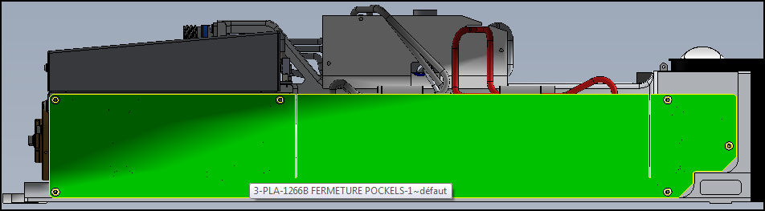

* Check the profile beam again

# SAVE THE PARAMETERS

* Save parameters (Nota : Cmd = FPGM two times)

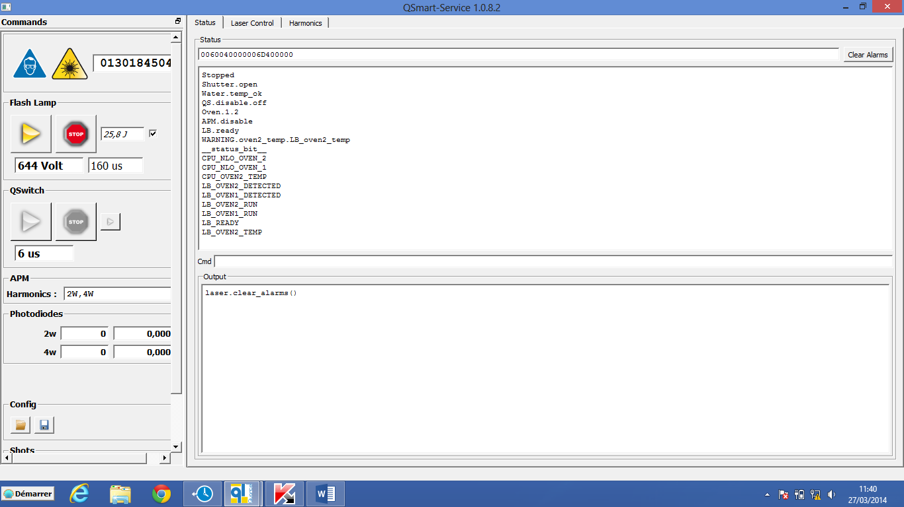

* Shut down and start again the power supply in order to check the parameters are save in the LB board

# FINISHING WORKS

* Shut down the power supply
* Disconnect the i/o power cable and coolant hoses
* Set up the cover and screw it

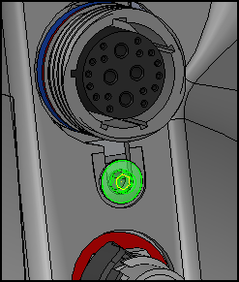

* Re-connect the i/o power cable and coolant hoses
* Check the energy of the Laser
* Check the beam profile on a burn paper at 30cm, 1m and 2m